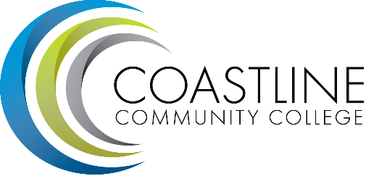
College Council Agenda
October 10, 2017; 9:00 – 11:00 a.m.
President’s Conference Room, College Center

Committee Mandate: To act on College committee and constituency recommendations, to foster College communication and information sharing, and to review overall College operations.

- CALL TO ORDER
  - Roll Call
  - Welcome
  - Adoption of **Agenda
  - *Approval of Minutes:
- September 26, 2017

- SPECIAL REPORTS/UPDATES
2.1 Constituency Updates
Associated Student Government (Carlos Bahena)
Academic Senate (Stephen Barnes)
Classified Senate (Kevin Donahue)
Management Team (Lori Adrian)

2.2 College Event Calendar
- CyberSecurity Awareness & Tech Expo, October 13, 2017, 6 – 9pm at GGC
- ASGCCC Event: Fall Carnival, October 26, 2017, 4 – 7pm at GGC
- CyberTech Girls OC, October 28, 2017, 9am – 2pm at GGC
- ECHS Day Event: November 1, 2017, 10am – 2pm at NBC
- ASGCCC Event: Stress Relief Therapy Dogs, December 6, 2017, 12 – 3pm at GGC

- PRESIDENT/VPs Brief Reports (Adrian, Groot, Nguyen, Rodriguez) (1-2 min)

4. ACTION ITEMS
  - Follow-Up on Action Items from July 11, 2017 meeting:
4.1.1 Stephen Barnes to discuss proposal of an additional representative to serve on the Facilities Committee in order to represent Art and Science. DEFERRED, Christine, Vince, Stephen & Debbie will meet on October 9 to discuss.
  - Follow-Up on Action Items from August 22, 2017 meeting:
4.2.1 Stephen Barnes will provide a report from the Governance Task Force along with a list of committee members. DEFERRED, Task Force meeting on October 12
4.2.2 Kevin will provide a list and a recommendation for faculty and staff to adhere to the college’s travel requirements related to the LDTQ and the Travel Ban to Dr. Adrian for presentation at Chancellor’s Cabinet. DEFERRED.
5. STANDING REPORTS
  - Budget Update (Christine Nguyen)
  - PIEAC (Stephen Barnes/Vince Rodriguez)
  - Program/Department Review (Stephen Barnes/Aeron Zentner)
  - Student Success Committee (Stephen Barnes)
  - Facilities, Safety & Sustainability (FSS) Committee (Christine Nguyen)
  - Technology Committee (Christine Nguyen/Joycelyn Groot)
  - Accreditation (Vince Rodriguez)
  - Financial Aid Federal Program Review (Lori Adrian)
  - Student Scorecard/Student Achievement Data
  - Guided Pathways (Lori Adrian/Aeron Zentner)

6. DISCUSSION ITEMS
6.1 College Committee List 2017-18
6.2 College Council Goals (Lori)

7. ANNOUNCEMENTS

- SUMMARY OF KEY ITEMS DISCUSSED/ACTIONS TAKEN

- ADJOURNMENT
9.1 Items for next meeting:
*Attachment has been emailed.
**Attachment available at meeting.

